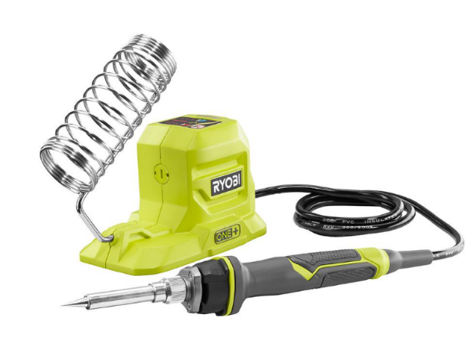

Technical Description of the RYOBI
ONE+ 18V 40-Watt Soldering Iron

Stefan Petrovic
Department of English, City College of New York
ENGL 20700: Writing for Engineering
Prof. Danielle Carr
September 22, 2021

Table of Contents
Page
Introduction 3
History of the Soldering Iron 3
History of RYOBI 3
The RYOBI ONE+ 18V 40-Watt Soldering Iron 4
Features & Specifications 5-6
Conclusion 7
Reference Page 8

Introduction
The idea of soldering goes far back to even 3000 BC where swords were made by combining metals. They would melt metals and combine them to make different tools and weapons. This process is similar to what a modern-day soldering iron does, we use it to melt a metal and join 2 or more things.
History of the Soldering Iron
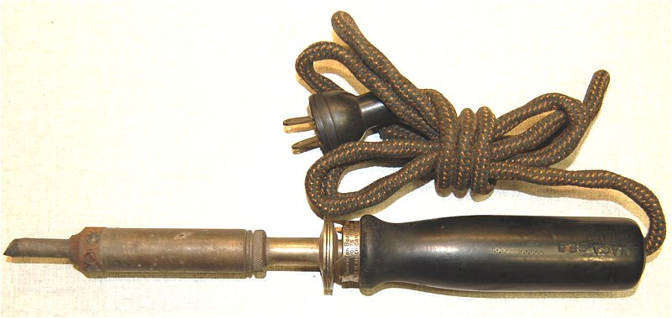
What we think of now when we hear soldering iron started to come into the world in 1926 by a man named William Alferink who applied and was granted a patent for what was described as a combination of an automatic circuit break for irons and a holder. But this innovation was out done 20 years later by Carl E. Weller who received a patent for his soldering gun that could instantaneously heat up. This created the production the first instant heat soldering gun. (Dan, 2021). “Production then immediately started for the “Speedy Iron” in Pennsylvania. He manufactured it through the Weller Manufacturing Company, and this product was the first instant heat soldering gun. Three years later, American Beauty started to sell an electric iron that you could adjust the temperature on.” (Dan, 2021).

Old Soldering Iron
(Sudo Null. n.d.).

History of RYOBI
Ryobi was founded in 1943 and started with the sale of die cast products. The next business ventures, the company set on was printing equipment and began manufacturing offset printing presses in 1961. It wasn’t till 1968 when they began the manufacturing of power tools, this business went well as they expanded operations worldwide and set up new offices and factories. From 1961 to now they have set up numerus corporations and have expanded greatly. Ryobi operates 12 manufacturing facilities across six countries. In 1985, Ryobi launched production in Shelbyville, Indiana, the companies only manufacturing location in the United States. However, in 2000 they sold Ryobi Power Tools and Ryobi Outdoor Power Equipment to Techtronic Industries with a license from Ryobi Limited. In the US you can mainly find Ryobi tools at Home Depot. (Ryobi, 2017).
Ryobi Logo
(Ryobi. 2017).

The RYOBI ONE+ 18V 40-Watt Soldering Iron
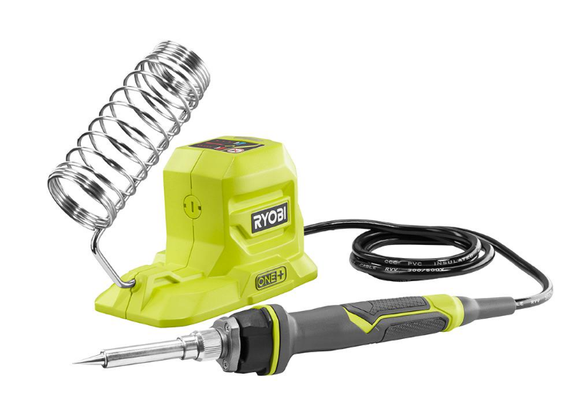
The RYOBI ONE+ 18V 40-Watt Soldering Iron (Figure 1) is a battery powered soldering iron. Since it is part of the 18V ONE+ system it uses the same 18v battery (Figure 2) as all tools in the system which makes an ecosystem for tools for your tool box. Since the iron is battery powered it makes it portable, meaning your workstation does not need to be next to an outlet and can be moved anywhere. The iron itself has a base with a holder for the hot iron and a LED indicator that when the tip has heated up. The base leads a 3-foot cord to the handle of the iron which is insulated to keep your hand from getting warm. At the other end of the handle is the tip which is the part that gets heated to a max temperature of 900℉. The tip can unscrew to be changed out and also to be maintained so that tip does not oxidize and become dull and lose the ability to heat fully. (Ryobi, n.d.)
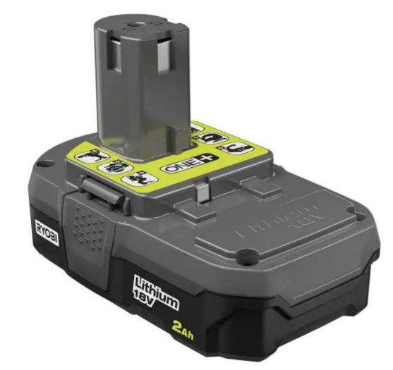

Figure 1
Ryobi. (n.d.).
Figure 2
Ryobi. (n.d.).
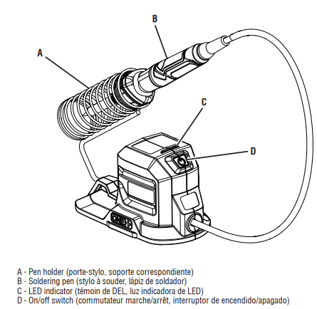
Figure 2
Ryobi. (n.d.).
Features & Specifications

Parts and Descriptions
- Pen Holder – Metal barrel that holds the iron securely and outer coil helps protect your hand from accidental contact. (Figure 3)
- Soldering Pen -The part that provides the heat from its metal tip in order to melt the solder. It has an insulated handle that keeps the heat away from your hand when it is in use. (Figure 3)
Figure 3 Tool diagram
(Ryobi. 2018)
- LED indicator – Indicates the status of the pen. If the led indicator is on the tip is heating up it will flash quickly until it reaches the maximum operating temperature. Once the maximum temperature is reached, the indicator will glow solid. The indicator will flash in a slow patter to indicate that the tip is cooling. (Figure 3)
Figure 4 Battery diagram.
(Ryobi. 2018)
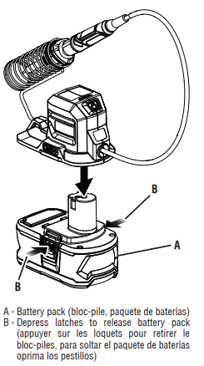
- On/Off switch - A button that turns on and off the pens heating. The tool has
an auto shut off and will automatic shut itself off after 10 minutes. (Figure 3)
- Battery pack - Provides power to the tool by clip into the bottom of the tool. The battery provides a base for the tool itself so it does not tip over. (Figure 4)
[Internal Parts]
- Heater wire – A wire that receives electricity and heats up the copper tip.
- Thermoresistant material – To protect other components from heat exposure.
- Thermostat – Tells the tool when the tip is at the right temperature and when it needs to head or stop.

Function/Use of the Item
[How to use RYOBI ONE+ 18V 40-Watt Soldering Iron]
- Attach the battery to the tool by clip it into the bottom of the battery. To remove depress the latches.
- Press the one and off switch to turn the power on. The LED will turn on and flash quickly and the tip will begin to heat up. When the LED is solid the tool is fully heated and can be used.
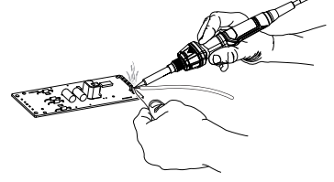
- Take to tool out of the holder and hold it as shown in figure 5.
- Apply solder to the tip of the tool as shown in figure 5.
- When finished place the tool back in the holder, turn it off and allow 30 minutes for it to cool before storage.
- To remove the tip: (Ryobi, 2018)
Figure 5 Battery diagram.
(Ryobi. 2018)
- Remove the battery pack from the tool.
- Loosen the nut by turning counterclockwise and remove from tip.
- Remove the sleeve by sliding off the pen.
- Pull to remove the tip and insert a replacement tip. Push the new tip onto the ceramic heating element.
- Hold the body of the pen and slide the sleeve over the new tip.
- Reinstall the nut.
⚠️ Safety and Maintenance (Ryobi, 2018)
- When you heat the tip before soldering apply a drop of solder to the tip in order to tin the tip.
- When you are done soldering wipe the tip against a damp sponge or
a metallic wool pad to remove debris.
- Always allow the soldering tip to cool for 30 minutes.
- Always remove the battery pack before storage to ensure the product is off.
- Use the tool in a well-ventilated area to not inhale the toxic fumes.
Conclusion
All together this tool is a great choice for a soldering iron and has many pros. The RYOBI ONE+ 18V 40-Watt Soldering Iron is a battery powered soldering iron. That has a base with a with a holder for the hot iron and has a fine point tip that heats up to 900F. The tip can unscrew to be changed out. The it ruction on how to use the tool are detail and there is also safety and maintenance info. In the end reader will have a good understand of what a soldering iron is and how to use one.

AUDIENCE PROFILE SHEET
Reader’s Name: New Soldering Iron Customer (Beginner)
Reader’s Job Title: Student
Education: College Level
Professional Experience: n/a
Job Responsibilities: Student in college that needs a soldering iron for a project.
Personal Characteristics: n/a
Cultural Characteristics: n/a
Attitude Toward the Writer: Neutral
Attitude Toward the Subject: Interested and curious.
Expectations About the Subject: Learning more about it.
Expectations About the Document: Get the knowledge and info necessary to use a soldering iron,
Reasons for Reading the Document: In order to get a better understanding on how a soldering iron works and how to properly use one.
Ways of Reading the Document:
Skimming it all ___
Reading specific parts needed ___
Reading Skills: Learning about electrical components. (Majoring in electrical engineering)
Reader’s Physical Environment: There college dorm or own room in home. Or college lab.

References
Dan. (2021, June 20). History 101 - the modern soldering iron. Hand Tools for Fun. Retrieved September 22, 2021, from https://handtoolsforfun.com/history-101-the-modern-soldering-iron/.
Sudo Null. (n.d.). Sudo null - latest it news. SudoNull. Retrieved September 22, 2021, from https://sudonull.com/post/28311-How-it-all-began-the-history-of-the-soldering-iron-and-the-advent-of-modern-tools.
Ryobi. (2017). History. RYOBI. Retrieved September 22, 2021, from https://www.ryobi-group.co.jp/en/corp/history.html.
Ryobi. (n.d.). 18V one+ 40w soldering iron. RYOBI Tools. Retrieved September 22, 2021, from https://www.ryobitools.com/products/details/33287176991.
Ryobi. (2018). 18V one+ 40w soldering iron manual. RYOBI Tools. Retrieved September 22, 2021, from https://manuals.ttigroupna.com/system/files/10821/original/P3105_414_trilingual_03.pdf?2021

Reflection
The audience of this technical description is anyone who is in the market for a Soldiering iron. This can be an amateur or new user or it can be an experience user like Metal workers, jewelers, electronics technicians and roofers. For the new users they can gain a better understanding on how a soldering iron works and how to properly use one. They can also get some good safety information so that they don’t get injured. For familiar users this technical description is useful to show of this type of tool as this one is battery power. It can show them the pros and cons of it and help them make a decision in their purchase. Anyone can have a question about this tool and this document with all its details and descriptions can probably answer those questions.
The purpose of this technical description is to inform, educate and explain all the aspects of the tool called RYOBI ONE+ 18V 40-Watt Soldering Iron. This document goes in-depth about this tool and includes valuable information on the History and origin of the tool, Features & Specifications like the parts and their descriptions and purposes. It also goes on to explain how to use the tool and what to watch out for.
My stance on this technical description is direct and understanding as I have used have and use this tool in my life. I have realized how useful it is to my carrier and know that other want to know how it works and how to use one. I have also thought people how to use it and this technical description would aid my teaching more.
The genre of this writing is technical. Specifically, a technical description which is a document that is written on a product for its user or potential buyer in order for them to understand how it works in great detail. My assignment is a technical description as it is contains all the aspects of one. It gives a background of history on the tool and it explains the, Features & Specifications like the parts and their descriptions and purposes. It also goes on to explain how to use the tool and what to watch out for.
The media of this technical description is a digital document. It is created using online research and typed up and give out online for peers to read.
My exigence for this technical description is that I wanted to show and share some information one a tool that I use and find useful to my work and college major. I chose this specific tool as it has some pros that I value and think it is one other the better options out there.

With this assignment, I have met the Course Learning Outcomes of practicing using various library resources, online databases, and the Internet to locate sources appropriate to my technical description. I have also engaged in genre analysis and multimodal composing to explore effective writing across disciplinary contexts and beyond since my writing will be posted and read by a reader for a purpose and I have also formulated and articulated a stance throughout by show a tool off (pg 3).

