Wildfire Detection System
Proposal, Technical Project
Plan A
to be presented on November 23, 2021

Stefan Petrovic
Georgy Orlov
Daniel Csukardi
Noel Tayao II

Gavin Newsom, Governor of California
Thom Porter, Director of the Department of Forestry and Fire Protection
Pamela Smith, Chief National Park Service

160 Convent Ave, New York, NY 10031
(212) 650-7000
development@wildfiredetectionsystems.org

TABLE OF CONTENTS
1. INTRODUCTION………………...……………………………………………………………..…….1
1.1 PROBLEM STATEMENT…………………………………………………………………..…1
1.2 BACKGROUND…………………………………………………………………………..…..1
1.3 NEEDS STATEMENT……..…………………………………………………………………..1
1.4 OBJECTIVE……………………………..…………………………………………………….1
2. PROPOSED TECHNICAL APPROACH
2.1 REQUIREMENTS……………………………………………………………………………..1
2.2 ARCHITECTURE DESIGN………………………………………………………………...1
2.3 IMPLEMENTATION DESIGN………………………………………………………………..1
2.4 QUALITY ASSURANCE PLAN………………………………………………………..…….1
3. EXPECTED PROJECT RESULTS
3.1 MEASURES OF SUCCESS…………………………………………………………………...1
3.2 COST…………………………………..……………………………………………………....1
4. SCHEDULE

1. Introduction
Climate change is increasing the temperatures throughout the world. Due to the gradual increase in heat, wildfires occur more frequently in areas prone to them. California is an area commonly affected by wildfires due to their already hot climate. Our objective is to design a unique detection system to pick up on these wildfires before they spread, that way firefighters can easily and safely put them out. Specifically, we are looking at Topanga State Park in Los Angeles because it is very close to homes and it is known for its wildfires. The expected benefits of this project will be reducing the damages done by wildfires and potentially saving lives.

1.1 Problem Statement
Detecting wildfires is very crucial to the planet's various ecosystems because they can be catastrophic to not only the wildlife but also the people living there as well. “From 2011 to 2020, there were an average of 62,805 wildfires annually and an average of 7.5 million acres impacted annually” (Wildfire Statistics. 2021). Since we depend on the forests for many of our natural resources, it is very important to detect any wildfires before they get too big. This way, they are not only easier to put out but also safer to do so as well.
It is hard to detect wildfires at their beginning. Usually, when the fire is detected it is too late, because it has a large area and it becomes larger every moment. Sometimes it is not even possible to deal with them and people need to evacuate from their homes so they do not get hurt.
Today most of the fires are detected by humans. When someone sees smoke, this person calls 911. It takes a big amount of time. Even if it is a trained person who sits in a tower and watches forest to detect smoke, it still takes about 10-30 minutes to report the fire and its location. And if people can see the smoke, it means the fire is already in action, and it has been in action for a while.
1.2 Background
Wildfires in California have been a problem for a long time now. Everybody in the world knows about them. The amount of acres burned and damage dealt by those fires are truly insane. The amount of fires each year is abnormal and the numbers only grow, because of the changes in climate. In 2021, there were 8,367 fires and the total area of the fires were 3,083,507 acres. For comparison, the average amount of fires, from the previous five years, is 5,581 and the average area is 843,301 acres (CAL FIRE, 2021). Nowadays a fire detection system is required more than ever.
Huge wildfires appear in the Topanga State Park almost every 10 years. For example, in 1993 there was one of the biggest fires in US history. “In 1993, the Old Topanga Fire raged over 18,000 acres, consuming 359 structures and killing three people” (New York Times, 2021). Another massive fire was in 2005. Based on the Earth Observatory Nasa, The fire has grown very fast. “Growing to more than 16,000 acres in around 2 days” (DBpedia, 2005). Fast fire growth has led to a significant amount of damage and people’s evacuation. “One home and handful of outbuildings had been lost. Mandatory evacuations were in place, involving at least 1,500 residents of the area” (DBpedia, 2005).
One of the reasons why those fires had large areas and dealt such damage, is that they were not detected early enough.

1.3 Needs STATEMENT
The project addressed the need to improve on the current technology available. Current wildfire detection methods are “...fire towers, aerial patrols, electronic lightning detectors, and automatic detection systems.” (Alkhatib, 2006) These methods cost a lot of manpower and money. Furthermore, the lightning detectors and automatic detection systems can be limited by range, along with a slightly slower response time in the case of fire towers and aerial patrols. What our project seeks to address is the implementation of a detection system that has increased range along with a cheaper cost. Currently, we seek to expand its range, lower its cost, and increase its efficiency in reporting a case of wildfire.
1.4 Objective
The object is to create a system that will detect wildfires as they appear so that the firefighters can put them out before they get too dangerous. By adding this fire detection system in Topanga State Park, we aim to ensure the safety of nearby residents by minimizing the scale of wildfires that occur there. The end goal is to offer a new way to combat the effects of climate change by limiting the damages done by these wildfires. This system will assist in making our ecosystems safer as well as putting human lives out of harm's way.
2. Proposed TECHNICAL APPROACH
The development and construction of the wildfire detection system will be split between 2 teams of engineers. One team consists of electrical engineers who would be considered the field team. They will be tasked with designing and installing a sensor system in the forest that will be the most effective in detecting a fire quickly. They will decide what methods of detection will be best for the forest by testing them in the forest they can use fire sensors, cameras, or drones. It could also be a combination of devices. The second team will be the computer scientists; they would be considered the control team. They will work on the computer’s system that processes what the sensor and cameras see in order to give an alarm when a fire is detected and will develop a program with AI that is trained to understand what a fire looks like. The two sides will be connected through satellites. With all of the development and construction completed, we expect the cost of materials to be $40,000. Once fully installed and tested, workers at the command center will be trained on how to monitor and act when the alarm sounds and how to maintain the system so it stays operational. First responders of the area can also receive training on understanding how to read where the wildfire is detected.
2.1 Requirements
- Devices - Sensors, Cameras, Drones
- Satellite communication
- Command center building
- Computers - With AI and machine learning software
- Alarm System
- Electrical Engineers
- Computer Scientists
- Monitoring Staff
- Maintenance Staff
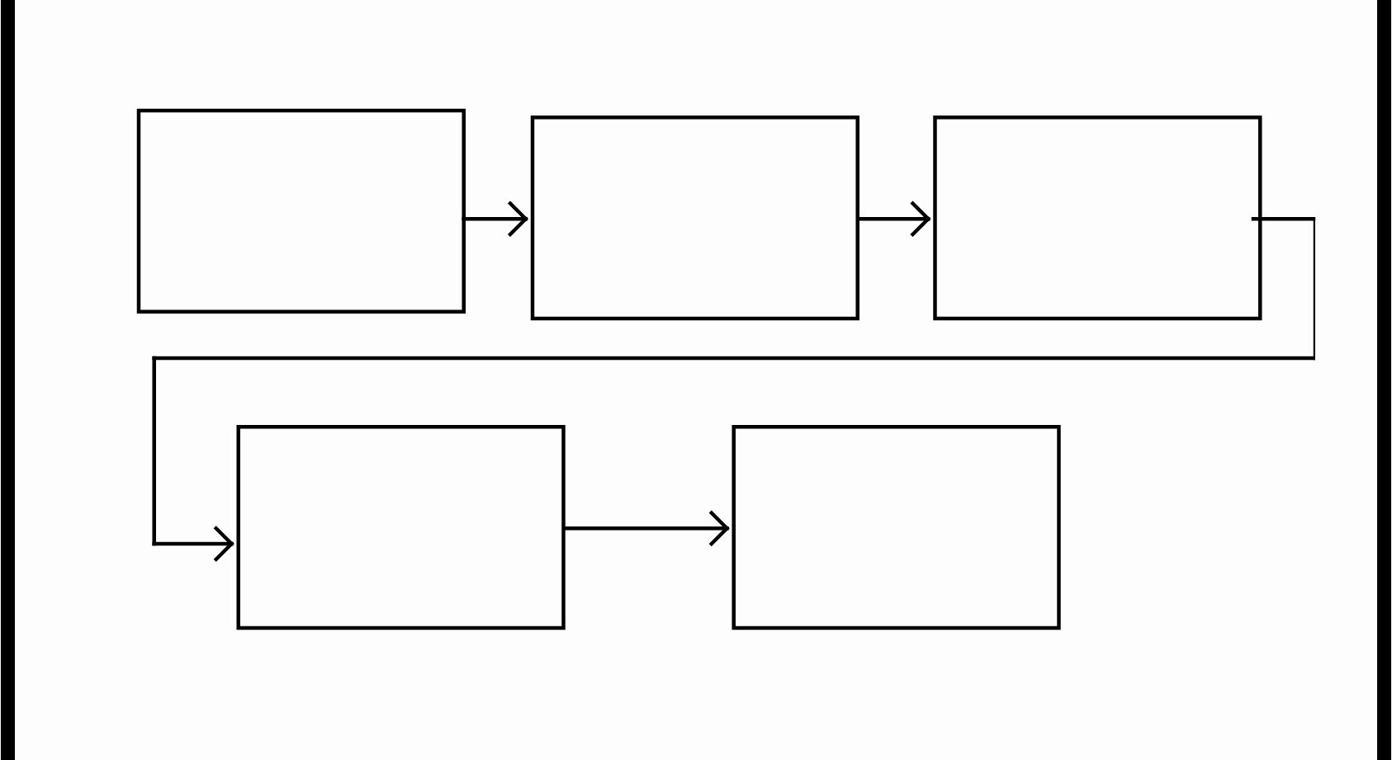
Figure 1. Block Diagram for System
First Responders
Cameras
Sensors
Drones
Satellites
Command Center
Computer with
AI and machine
learning algorithms

2.2 Architecture Design
The wildfire detection system will have many technologies powering it. The technology begins with the hardware then moves with the network to the software.
- Hardware: Fire Camera, Fire sensors, Drones
- Software: Computers running AI and machine learning algorithms.
- Network: Communication over existing satellites.
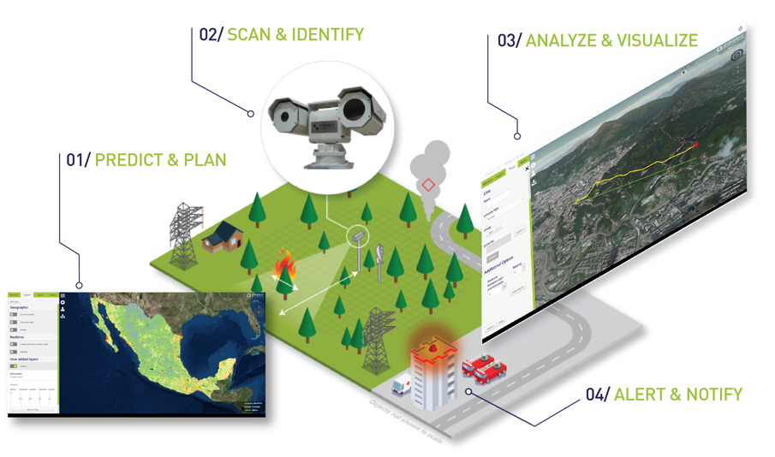
The hardware components are the devices placed in the forest that scan the forest 24/7, these devices can be cameras, sensors, or drones. The data from these are sent to the command center using the network of existing satellites; the footage from cameras and data from sensors is sent with a GPS mark for tracking. This then goes into the computers with the software that can analyze what is a fire using AI and machine learning algorithms.

Figure 2 Architecture diagram
(Insight. 2019)
2.3 Implementation DESIGN
To design, install and test the wildfire detection system the electrical engineering team will need to travel to the forest and survey it in order to select and design a method of detection. Then they will then install the hardware into the forest. The computer science team will set up the command center by installing the computers and software running AI and machine learning algorithms. They will connect the hardware with the software over the satellite network. Once completed the system will be tested and adjustments could be made. Once fully installed and tested, workers at the command center will be trained on how to monitor and act when the alarm sounds and how to maintain the system so it stays operational.
2.4 Quality Assurance Plan
To deliver a successful and effective system it is necessary to test and adjust. With this, the risks of failure in the software are minimized and will ensure 100% accuracy. Some risks with the system can be dirty or damaged cameras, faulty sensors, satellite failure or blockage, and command center power loss or hardware power loss. Here is a list of a multipoint inspection that is performed regularly:
- Cameras
- Sensors
- Satellite communication
- Computer software
- Backup power
This inspection and test ensures that each component is working properly and allows for a complete and functioning system to be delivered 24/7. The software is outfitted with a fail-safe feature that can monitor the component and can alert if there is something out of ordinary. If something seems to have failed it will be replaced or adjusted and will be tested again to make sure the problem is resolved.
3. Expected Project Results

- An increased range from 25 miles to 30 miles.
- A faster detection speed
- Less reliance on human reports
- Lower cost in making the product
- More fires detected overall

3.1 MEASURES of SUCCESS
After one year of our wildfire detecting system being installed, we will compare how fast our system has detected wildfires, which happened during the year, to the speed of detection by the old systems. Also, we will compare the number of fires detected.
Right now fire detection takes about 10 minutes with the infra-red cameras and human reports. Our projected value for fire detection is 5 minutes.
We expect an increase of wildfires detected, because the range of our system is slightly larger. Also, because of the range increase, the need for human reports is expected to be lower.

3.2 Cost
Equipment/Payroll: | Cost:
Camera | $3,500
Drone | $2,000
Sensors | $1,500
Computers | $10,000
Command center building | $10,000 per year
Personnel | $100,000
Maintenance | $10,000 per year

4. Schedule
Time used | Task
3 Weeks | Forest Survey - Collect information on the forest and its geography.
2 week | Pick hardware and design a method of detection.
2 weeks | Install Hardware
2 weeks | Set up a command center in the preselected building and install the computers and software running AI and machine learning algorithms.
2-3 days | Connect the hardware to the network and then to the software
2 weeks | System testing and multipoint inspection.

References
Alkhatib, A. A. A. (2006, June 1). A review on forest fire detection techniques - Ahmad A.
A. Alkhatib, 2014. SAGE Journals. Retrieved November 18, 2021, from
https://journals.sagepub.com/doi/full/10.1155/2014/597368.
Lowe, J. (2021, June 19). 'if you move out here, you make a deal with nature': Life in a
fire-prone canyon. The New York Times. Retrieved November 18, 2021, from
https://www.nytimes.com/2021/06/19/us/topanga-canyon-wildfires.html.
California Department of Forestry and Fire Protection (CAL FIRE). (2021). Stats and
events. Cal Fire Department of Forestry and Fire Protection. Retrieved November
18, 2021, from https://www.fire.ca.gov/stats-events/.
Insight Robotics wildfire detection system. Insight Robotics. (2019, November 6).
Retrieved November 18, 2021, from
https://www.insightrobotics.com/en/services/wildfire-detection-system/.
Topanga Fire. DBpedia. (2005). Retrieved November 18, 2021, from
http://live.dbpedia.org/resource/Topanga_Fire.
Wildfire Statistics - Federation of American scientists. (n.d.). Retrieved November 8, 2021,
from https://sgp.fas.org/crs/misc/IF10244.pdf

AUDIENCE PROFILE SHEET
Reader’s Name: Gavin Newsom
Reader’s Job Title: Governor of California
Education: College Level
Professional Experience: Multiple terms as mayor in San Francisco and Governor of California.
Job Responsibilities: Making the annual State of the State address to the California State Legislature, submitting the budget, and ensuring that state laws are enforced.
Personal Characteristics: n/a
Cultural Characteristics: n/a
Attitude Toward the Writer: Neutral
Attitude Toward the Subject: Interested and curious.
Expectations About the Subject: Get informed
Expectations About the Document: Get the knowledge and info on the product and innovation.
Reasons for Reading the Document: Get an understanding of a new company and its product to aid people in your community.
Ways of Reading the Document:
Skim it? [Yes]
Reading specific parts needed ___
Reading Skills: Background knowledge on natural issues and the need to address them.
Reader’s Physical Environment: Governor’s office.

AUDIENCE PROFILE SHEET
Reader’s Name: Thom Porter
Reader’s Job Title: Director of the Department of Forestry and Fire Protection
Education: College Level
Professional Experience: He served as the Chief of Strategic Planning in Sacramento Headquarters since January 1, 2018. Previously, he served as the Southern Region Chief, Assistant Southern Region Chief, and the San Diego Unit Fire Chief.
Job Responsibilities: Operational responsibility for all forestry and fire protection activities in the Region
Personal Characteristics: n/a
Cultural Characteristics: n/a
Attitude Toward the Writer: Neutral
Attitude Toward the Subject: Interested and curious.
Expectations About the Subject: Get informed
Expectations About the Document: Get the knowledge and info on the product and innovation.
Reasons for Reading the Document: Get an understanding of a new company and its product to aid people in your community.
Ways of Reading the Document:
Skim it? [Yes]
Reading specific parts needed: [X]
Reading Skills: Background knowledge on natural issues and the need to address them.
Reader’s Physical Environment: Office

AUDIENCE PROFILE SHEET
Reader’s Name: Pamela Smith
Reader’s Job Title: Chief of U.S. Park Police
Education: College Level (Bachelors in Science)
Professional Experience: Smith has served as a commander of the New York Field Office, acting deputy chief of the Homeland Security Division, and deputy chief for the Field Operations Division. From Febuary 28, 2021 to present, she is the Chief of the National Park Police.
Job Responsibilities: Leader of a unit under Federal Parks; investigates possible crimes in a park, as well as accidents.
Personal Characteristics: n/a
Cultural Characteristics: n/a
Attitude Toward the Writer: Neutral
Attitude Toward the Subject: Interested and curious
Expectations About the Subject: Curious on how it can aid in police duties
Expectations About the Document: Possible info on a product that can lead
Reasons for Reading the Document: Possible implementation in arson based crimes or unintentional fire accidents
Ways of Reading the Document: Skim it? [Yes]
Reading specific parts needed: [X]
Reading Skills: Background info on wildfires, but needs more elaboration on more technical areas
Reader’s Physical Environment: Office

Reflection - Stefan Petrovic
The audience of this engineering proposal is 3 key people Gavin Newsom, Governor of California Thom Porter, Director of the Department of Forestry and Fire Protection, and Pamela Smith, Chief National Park Service. These people not only have the power to implement our tech but they also have some knowledge of the problems and want is needed to fix them.
The purpose we have is to reach our audience of Gavin Newsom, Governor of California Thom Porter, Director of the Department of Forestry and Fire Protection, and Pamela Smith, Chief National Park Service to look into our innovation and system and implement it in the Topanga State Park to detect fires faster and do it effectively all with to goal, to prevent them from dealing damage to people and buildings in this area.
My stance on this engineering proposal is that it is helpful toward a massive threat that people have to deal with. In recent years wildfires have been getting more common and bigger, they pose a huge threat and have caused a lot of damage. That is why modern technology would greatly be able to help.
The genre of this assignment is an engineering proposal. Which is a document for which engineering consultant selection decisions are made. They are made to showcase a problem and a solution in detail so an audience can understand it
The media of this assignment is digital and presentation. Our group posts the draft on Blackboard. After that, we need to do a peer review for another group and vice versa. After receiving a review, we post our final version of the proposal on blackboard. Finally, we make a presentation and present our proposal to our classmates and instructor.
My exigence for this engineering proposal is that we needed a issue that can be tackled using our skills. With that in mind, we made a system of sensors and AI to solve forest fires that affect our nation. With that, in mind, we can help our county with a challenge that can get worse we don’t help.
With this assignment, I have met the Course Learning Outcomes of using various library resources, online databases, and the Internet to locate sources. I engaged in genre analysis and multimodal composing to explore effective writing across disciplinary contexts and beyond. I developed and engage in the collaborative and social aspects of writing processes, because it was a group assignment. And I strengthen your source use practices (including evaluating, integrating, quoting, paraphrasing, summarizing, synthesizing, analyzing, and citing sources).

Georgy Orlov
When the professor announced the assignment, I was scared at first. My thoughts were: that is a very big and complex assignment, I have no idea what we will write about, such a big project means a large responsibility on each group’s member. But everything went smoothly. My group appeared to be responsible and productive. At first, we could not decide what topic to choose, but we all agreed that we need to do something about wildfires, because during this year in the US there were a lot of them, and it is one of the biggest nature problems. After some research we decided to create a system that will detect the wildfires faster than the systems which exist now, so the fire department will have more time to deal with the threat. Then we thought about the technologies which we will use and finally the region where we want to install our system. The final project is to install the wildfires detective system, which uses drones, cameras, and AI to detect the fires in the Topanga State Park in Los Angeles.

The genre of this assignment is an engineering proposal. The proposal is to install our wildfires detective system in the Topanga State Park. The system will use an AI which will recognize the fire by footage from the drones and cameras. This system will reduce the detection time from 10 to 5 minutes and will cover more range than it is covered right now. It will detect more fires and it will reduce the human factor in fire detecting.
The media of this assignment is online and presentation. Firstly, our group posts our draft of an engineering proposal on the Blackboard. After that we need to do a peer review for another group and vice versa. After receiving a review, we post our final version of the proposal on blackboard. Finally, we make a presentation and present our proposal to our classmates and instructor.
My stance towards this engineering proposal is that since I moved to the US three years ago, every summer I hear about how big and dangerous wildfires are and how much damage they deal to people and surroundings. It is truly one of the biggest nature problems in the US. And in my view, with modern technologies there should not be such a big problem to deal with them.
Our purpose is to convince next people: Gavin Newsom, Governor of California, Thom Porter, Director of the Department of Forestry and Fire Protection, Pamela Smith, Chief National Park Service, on implementing our system in the Topanga State Park to detect fires faster and accurately, to prevent them dealing damage to people and buildings in this area.
The audience of our engineering proposal is: Gavin Newsom, Governor of California, Thom Porter, Director of the Department of Forestry and Fire Protection, Pamela Smith, Chief National Park Service. We believe that those people have the authority to implement our wildfires detecting system and have the knowledge about why it should be implemented.
This assignment meets all of the learning outcomes. It meets “acknowledge your and others' range of linguistic differences as resources, and draw on those resources to develop rhetorical sensibility”, because I needed to do a lot of research about wildfires and their detection. I looked through different researches to understand what systems already exist and how we can improve them. It meets “enhance strategies for reading, drafting, revising, editing, and self-assessment”, because this assignment requires research, draft work, peer review and more. This implies all of the things above. It meets “negotiate your own writing goals and audience expectations regarding conventions of genre, medium, and rhetorical situation”, because we needed to consider our audience during this assignment, to persuade them to install our system. It meets “develop and engage in the collaborative and social aspects of writing processes”, because it was a group assignment and we needed to work together. It meets “engage in genre analysis and multimodal composing to explore effective writing across disciplinary contexts and beyond”, because this assignment has a multimodal media. We need to do paperwork as well as the oral presentation. It meets “formulate and articulate a stance through and in your writing”, because I believe that wildfires are a big problem, and we can try to propose a solution with modern technology to make it smaller. This assignment meets “practice using various library resources, online databases, and the Internet to locate sources appropriate to your writing projects”, because during this assignment I was looking at different types of sources, different data tables and more, such as: Fire department sites, wildfires statistics, detections systems. This assignment meets “strengthen your source use practices (including evaluating, integrating, quoting, paraphrasing, summarizing, synthesizing, analyzing, and citing sources)”, because when I used the researched information in the assignment, I always needed to cite it properly and avoid plagiarism.

Reflection Paper- Noel Tayao II

In collaborating on this project, I was nervous about my contributions and the work I will have to do. To be more specific, will I be able to support and help my group out well? This was slightly alleviated when we discussed our topic for this proposal: something to alleviate the wildfires that appeared all around the world. While we could have contributed to something for Climate Change, we realized that wildfires is a topic that was talked about less, even though climate change is one of the reasons why it happens more often. It is an overlooked problem that does not get much attention until something major happens. As such, our group decided to run with the idea of making a system to detect wildfires faster than its current rate.

Once we had an idea to write about, we went to research it. What would be included in our project? How would these items benefit our purpose? Questions such as these made us discuss what would be included and where we should theoretically implement these changes. After a while, we settled on one of the forests in California, as it is a place with a high rate of wildfires in America. We did our project while on a Discord call and divided the work. I addressed what our project sought to address upon improving any previous models. Along with that, I did some research on the current wildfire detection methods. One of the things I discovered was the fact that a portion of wildfire reports were made from a manual report. This was an issue that our team would want to resolve. This made our train of thought go in the direction of improving this method by increasing its range and cost-effectiveness rather than trying to brainstorm something new.

In this project, I learned how to better coordinate in a group. We all contribute to a portion of the work, and should one of us be hindered, all of us will be hindered. Our work needs to be combined seamlessly to make a good result, and each of us should be prepared to overview and improve upon each other. We need to construct a good proposal, so the person that we are sending our proposal to will realistically accept it. It is one of the many things I can improve on as of now.

The audience for the description is Gavin Newsom, Governor of California, Thom Porter, Director of the Department of Forestry and Fire Protection, and Pamela Smith, Chief National Park Service. These individuals have the power to bring changes for the topic we are proposing about. The purpose of our proposal is to propose an improvement to the current methods of detecting wildfires to the audience. We hope to convince them to accept our proposal so it can be implemented in forests and parks to improve the detection and lower the need for human wildfire reports.

My stance on this proposal is that it is something that can help a massive issue that puts people’s lives at risk. As time goes on, the chances of wildfires appearing can only increase due to the rising climate. What we need is a more efficient way to detect this issue as it grows, as prevention and a fast response is the best way to resolve the wildfire problem. The genre of this project is an engineering proposal, where engineering projects are written down and submitted to the government. Engineering proposals describe projects that resolve problems in detail to the audience so they can understand its significance.

The media of this project is digital and a presentation. We had to present our project for a peer review, as well as submit our final draft on Blackboard. We do not have this project on paper, as it is all done online. My exigence for the project is how we can combine our skills to tackle a specific issue. We needed an issue that can address our skills, so we used the wildfire issue to apply for some part of each of our intended majors. This was an issue that needed to be addressed, as it can only get worse every year.

This assignment meets the course learning outcomes of developing and engaging in the collaborative and social aspects of writing processes, acknowledge your and others' range of linguistic differences as resources and drawing on those resources to develop rhetorical sensibility, and negotiate your own writing goals and audience expectations regarding conventions of genre, medium, and rhetorical situation. In this project, we had to collaborate with our group in order to create an engineering proposal. We had to check and proofread each of our typed sessions, as we have a different style in writing/typing. We had to discuss and settle on a course of action based on how our audience may react. Our audience are individuals who have a limited amount of time and are highly professional.

Reflection Paper - Daniel Csukardi

The genre of this assignment is an engineering proposal. What an engineering proposal means is that a problem is presented and then a solution is followed up with an in depth discussion on how the solution will work. This proposal is about setting up a wildfire detection system in Topanga State Park.
Our purpose is to convince our audience: Gavin Newsom, Governor of California, Thom Porter, Director of the Department of Forestry and Fire Protection, Pamela Smith, Chief National Park Service. We want to convince them to look at our new system and implement it in Topanga State Park to detect wildfires more frequently and effectively. The goal is to reduce damages done by wildfires and save people from danger.
The audience of our engineering proposal is: Gavin Newsom, Governor of California, Thom Porter, Director of the Department of Forestry and Fire Protection, Pamela Smith, Chief National Park Service. These are the most logical people to get into contact with because they have a lot of knowledge when it comes to this topic but not only that, they have the power to make the changes necessary.
My stance on this engineering proposal is that it is a necessity that is capable of saving lives. Wildfires continue to grow in numbers and pose a threat to our ecosystems therefore they are a huge issue. They cause massive amounts of damage and are dangerous to anyone in the immediate area.
The media of this project is digital and a presentation. We posted the draft on blackboard for peer review and then made the final revisions. We then present it live to our classmates and professor.
My exigence for writing this engineering proposal was to combine the groups different skills and focus on one particular issue. This issue needed to address our skills so we came up with wildfires since it gets worse and worse as the years go by. So we made an AI to detect wildfires more easily.
With this assignment, all learning outcomes are met. I have researched wildfire detection systems through the internet, various online databases, and library resources. We had to work together as a group and use our skills to create this engineering proposal. Since this was a group assignment, I have engaged in the social aspects as well as the collaborative aspects of the writing process. We have proofread each other's work and made sure everything was written in the most effective and logical way. I also cited every resource and database I used to avoid plagiarism and ensure my credibility and accuracy.

