How to make NYC Busses more efficient

Stefan Petrovic
Department of English, City College of New York
ENGL 20700: Writing for Engineering
Prof. Danielle Carr
October 19, 2021

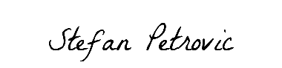
Table of Contents
Page
Abstract 3
Introduction 4
Materials 4
Methods 5
Results 5
Discussion 6
Conclusion 7
Reference Page 8

Abstract
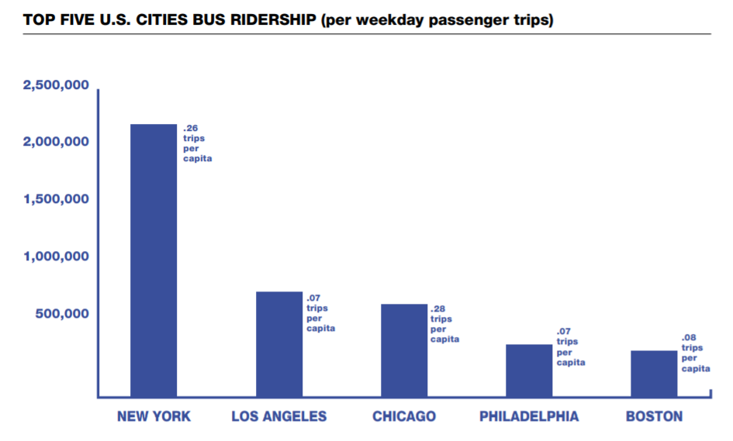
NYC is one of the largest and most important cities in the world, therefor its transportation system is crucial to its function. While the NYC transportation system has many elements like subways, busses, PATH trains, AirTran’s, commuter rail and even a tramway. To test and improve all of them at once would be far to large of a task for one team. Our team went with the MTA Bus system since when people talk about transportation improvements, they focus on the MTA Subway system and that causes the bus system to lack. We want to make NYC busses more efficient and reduce delays by figuring out the best changes to implement we would do this by pick 2 bus lines one regular and one select that both have a similar distance. We would then measure the delays the busses encounter and the scheduling during the morning rush hour which is from 7:30 am to 9:00 am to see what is slowing them down or speeding them up. After gathering data on these bus lines, we saw some standout issues with busses but we also saw what speeds them up. We saw that if a bus had access to a bus lane then it would travel 2 times the speed then it does without it. If that was pared with TSP intersections, they would spend less time stopped and instead moving which eliminate delays due to traffic. With all door boarding there does not seen to be a large advantage since the ticket checks take too long and there were only few bus stops where there was a lot of people to board. But we believe that if omny get fully incorporated into the bus system and MetroCard’s are eliminated then all door boarding will be better since omny can be at every door. All in all, the biggest delay to busses is traffic so adding technology like TSP intersections and more bus lanes is the best way to improve the MTA bus system.

Bus ridership in the U. S
(GOV. N.D)

Introduction
The NYC transportation system has many elements like subways, busses, PATH trains, AirTran’s, commuter rail and even a tramway. They all work in unison to get people where they need to go. The MTA runs the subway and busses and when they talk about system improvements the focus on the subway system and its infrastructure, forgoing the bus system. With NYC having the most bus riders in the nation (GOV. N.D) its critical to improve its infrastructure and system as well. Without improvements to the whole system, it allows for holes in service which affects the performance and therefor customer satisfaction and profits drop. To improve system, we hypothesis that by adding more bus lanes, tsp intersections, and all-door boarding to busses it will improve system efficiency. This comes as the number one factor slowing down busses its traffic congestion (Forman. 2018). To test to see if hypothesized improvements work, we would pick 2 bus lines one regular and one select that both have a similar distance. We would then measure the delays the busses encounter and the scheduling during the morning rush hour which is from 7:30 am to 9:00 am to see what is slowing them down or speeding them up. By doing this we can get real data on what is slowing busses down and what helps speed them up, with this data smart changes can be made to implement things that work to aid the bus system therefor improving service and customer satisfaction.
Materials
- Stopwatch
- Timetable
- Phone
- MetroCard
- Notepad
- 4 People
  - One on the bus
  - One on the first stop
  - One on the last stop
  - One mission control that talks to each person and takes there notes and findings.
Methods
To start, pick 2 bus lines one should be a regular service and the other a select bus service these bus lines should be similar in length. If one is shorter then it should have more stops. The Q69 and the M60SBS are good choice of busses. They both start from the same bus depot and start their lines in the same neighborhood. The Q69 route has no all door boarding on its busses, it uses no bus lanes and the route length is 5 miles. The M60SBS has all door boarding it has 1.22 miles of bus lanes on its route and the total route length is 7 miles. The M60 is 2 miles longer as it crosses the Triboro bridge which as no stops so it matches up with the Q69. One person would be at the first stop of the line. They would keep track of the bus’s departure from the first stop and keep record if it follows the official schedule and note any delays or issues that cause it to depart late. One person would be at the last stop. They would keep track of the bus’s arrival to the last stop and will keep record if it is following the official schedule and note any delays or issues that cause it to arrive late. One person would be on the bus. They would ride the bus and time and note multiple things. The notes should contain the time the bus took to reach the last stop, the time at each bus stop, the time the bus is at a red light, the time the bus is stuck in traffic and the issues the bus encounters that slows it down. The last person would be mission control. They would communicate with the 3 people out in the field and take their note and comments, they will also look at live traffic maps to see congestion and traffic delays the bus could run into. All this data will be organized by mission control to be interpreted and find a result from the observations.
Results
Our results contain 2 major things:
What slows busses down.
What features speed busses up.
The table below shows the things we observed that slow busses down. The lowest is bus bunching 20%, which is when to many busses try to use a station and there is not space therefore causing traffic at the bus stop. The next the traffic lights 23%, this is the time a bus spends a traffic light. The next is bus lane or road obstructions 28%, this includes people double parking in traffic and bus lanes. The top factor is traffic congestion with 72% , many times have we seen busses get stuck in rush hour traffic.
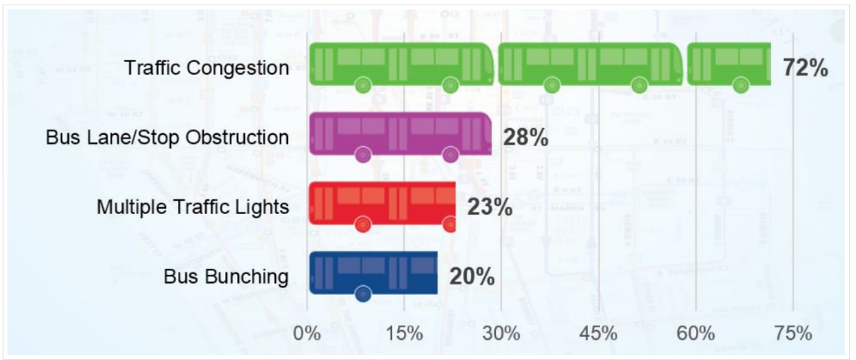
Features tested that should speed up busses.
Key factors causing bus delays
(Forman. 2018)
Feature | Effect
Bus Lanes | Increases the speed of busses 2x.  1.5 times less likely to be blocked.
TSP Intersections | Busses spend 5x less time at a red light.
All Door barding | No real change:  - Works when there are many people at a bus stop.  - The ticket checks take to long.

Discussion
What we have found during the experiment come down to 2 tings. What factors and issues slow busses down and what feature speed busses up? While riding on the 2 chosen bus lines we noticed 4 standout issues slowing the busses down. The smallest issue is bus bunching where too many busses show up at the same bus stop and therefore cause traffic at the stops slowing them down. The next issue was traffic lights with almost every block having one it contributes to a lot of time spent not moving. Next would-be bus lane or road obstructions this includes people double parking in traffic and bus lanes and roadwork. If a lane of travel is blocked time needs to be spent to go around and if a bus lane is blocking the that defeats its purpose. And finally, traffic which at rush hour is extremely heavy and can take up a lot of time. With that said the features that we looked at that can improve this are bus lanes, tsp intersections and all door boarding. Using bus lanes would increase the speed of the bus 2 times and using TSP intersections with it would make the bus almost never wait at lights, but all door boarding is not the best since the ticket checks take too long and there were only few bus stops where there was a lot of people to board. With that said the hypothesis was partially correct, adding more bus lanes and tsp intersection would vastly improve bus efficiency, however all door barding would have little to no effect on efficiency.
Conclusion
All in all, this experiment has shown us the different ways the MTA bus service suffers in terms of speed and efficiency. We wanted to test the system bus system to see which improvements give the best results. Our hypothesis was that adding more bus lanes, tsp intersections, and all-door boarding to busses it will improve efficiency. After the experiment we saw that if a bus had access to a bus lane then it would travel 2 times the speed then it does without it. If that was pared with TSP intersections, they would spend less time stopped and instead moving which eliminate delays due to traffic. With all door boarding our hypothesis was wrong since there does not seen to be a large advantage to the efficiency of the system. These finding can help focus the improvements of the bus system and show developers what changes work and what don’t, it also uncovers new issues that can be solved. All to make the bus system better.

References
Forman, A. (2018, April 20). Improving Select Bus Service: Putting the Rapid in Bus Rapid Transit. Comptroller.nyc.gov. Retrieved October 13, 2021, from https://comptroller.nyc.gov/reports/improving-select-bus-service-putting-the-rapid-in-bus-rapid-transit/\.
GOV, N. Y. C. (n.d.). Better Buses Action Plan 2019 - New York City. Retrieved October 13, 2021, from https://www1.nyc.gov/html/brt/downloads/pdf/better-buses-action-plan-2019.pdf.
GOV, N. Y. C. (n.d.). Better Buses. Retrieved October 13, 2021, from https://www1.nyc.gov/html/brt/html/betterbuses/betterbuses.shtml.

AUDIENCE PROFILE SHEET
Reader’s Name: Craig Cipriano
Reader’s Job Title: President of New York City Transit
Education: Masters
Professional Experience: 30 years of public transit experience and proven success as a strategic leader delivering customer-focused, technological, and data-driven solutions to improve bus and paratransit operations.
Job Responsibilities: Responsible for a $3.7 billion budget, strategic policy, planning, and performance for a combined bus and paratransit annual ridership of approximately 700 million, with 49 operating locations across the New York City metropolitan area and approximately 7,400 bus and paratransit revenue vehicles.
Personal Characteristics: n/a
Cultural Characteristics: n/a
Attitude Toward the Writer: Neutral
Attitude Toward the Subject: Interested and curious.
Expectations About the Subject: Interested.
Expectations About the Document: Get the knowledge and info necessary about bus speed data and improvements.
Reasons for Reading the Document: In order to get a better understanding on bus speed data and improvements that work.
Ways of Reading the Document:
Skimming it all ___
Reading specific parts needed ___
Reading Skills: Well versed in public transit and a college education that relates to it.
Reader’s Physical Environment: Office
Reflection
The audience would be the President of New York City Transit Craig Cipriano, he makes the changes to the NYC bus system so if we give him that data with ideas it could be put to use by his team. He has a City and Regional Planning master’s degree and has proven success as a strategic leader delivering customer-focused, technological, and data-driven solutions to improve bus and paratransit operations. He has also worked on Bus Network Redesign for the borough of Staten Island.
The purpose of this lab is to make the NYC busses more efficient and reduce delays by figuring out the best changes to implement. When people talk about transportation improvements, they focus on the MTA Subway system and that causes the bus system to lack. Without improvements to the whole system, it allows for holes in service which affects the performance and therefor customer satisfaction and profits drop. That is why it is important to always find improvements.
My stance on this lab report is direct as I use the MTA bus system regularly, as I used the system since I was little, I noticed that the bus system has not gotten as many improvements as the subway system did. So, if I can find out what can be improve it would help my experience and help me get where I need to go faster.
The genre of this writing is a report. Specifically, it is a lab report with is a document that outlines and explains what was done in an experiment. It goes to explain that way the experiment was done and the findings.
The media of this lab report is a digital document. It is created using online research and typed up and give out online for peers to read.
My exigence for this lab report is that I wanted to find out and share some information on how to make MTA busses more efficient.

With this assignment, I have met the Course Learning Outcomes of practicing using various library resources, online databases, and the Internet to locate sources appropriate to my lab. I have also engaged in genre analysis and multimodal composing to explore effective writing across disciplinary contexts and beyond since my writing will be posted and read by a reader for a purpose and I have also formulated and articulated a stance throughout. (pg 3).

